📘 Breast Cancer Classification – Logistic Regression﻿
Step-by-Step Notes (Text Form)﻿
---﻿
1. Importing Required Libraries﻿
Pandas (pd)﻿
Used for loading, manipulating, and analyzing structured datasets.﻿
NumPy (np)﻿
Provides support for numerical operations and arrays.﻿
Matplotlib (plt)﻿
Used to create basic plots and charts.﻿
Seaborn (sns)﻿
Built on Matplotlib, used for advanced and visually appealing plots.﻿
Scikit-learn (sklearn)﻿
Used for:﻿
Splitting data into train and test sets﻿
Feature scaling﻿
Model training﻿
Model evaluation﻿
---﻿
2. Loading and Exploring the Dataset﻿
df = pd.read_csv('breast_cancer_data.csv')﻿
Loads the CSV file into a Pandas DataFrame.﻿
Each row represents one patient.﻿
Columns represent features and the target variable.﻿
Common Exploration Commands (optional)﻿
df.head() → Displays the rows.﻿
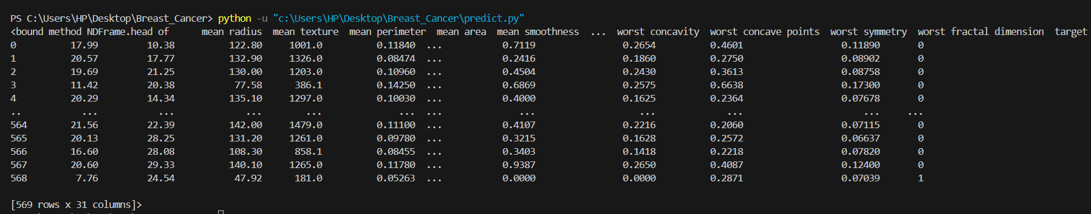

df.info() → Shows column data types and missing values. ﻿
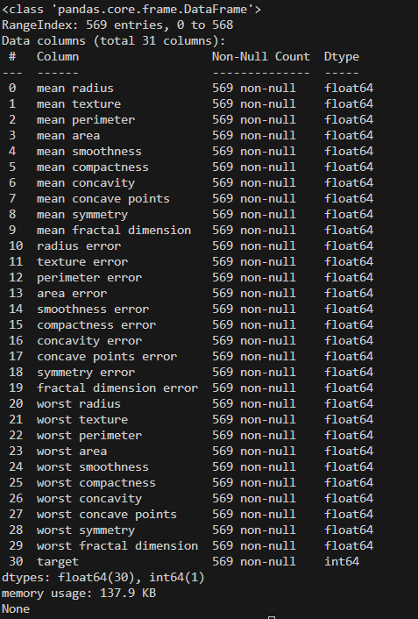

df.describe() → Provides statistical summary of numeric columns.﻿
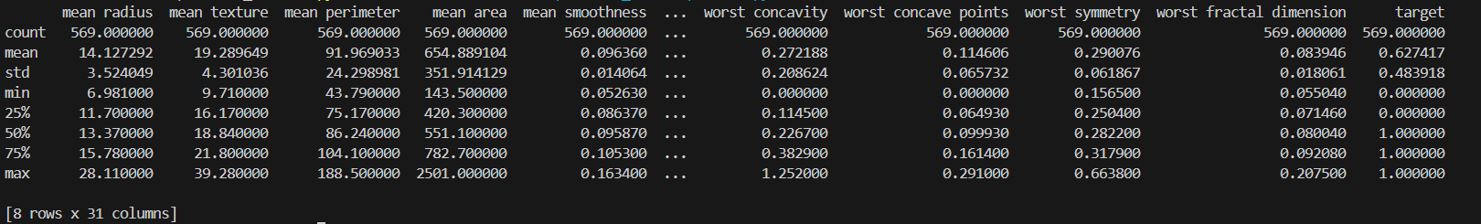

3. Data Preprocessing﻿
3.1 Separating Features and Target﻿
X = df.drop('target', axis=1)﻿
y = df['target']﻿
X (Features): All independent variables.﻿
y (Target): Dependent variable (binary classification: 0 or 1).﻿
---﻿
3.2 Train-Test Split﻿
X_train, X_test, y_train, y_test = train_test_split(﻿
X, y, test_size=0.2, random_state=42﻿
)﻿
Splits the dataset into:﻿
80% training data﻿
20% testing data﻿
random_state=42 ensures reproducibility.﻿
---﻿
3.3 Feature Scaling (Standardization)﻿
scaler = StandardScaler()﻿
X_train = scaler.fit_transform(X_train)﻿
X_test = scaler.transform(X_test)﻿
Converts features to a standard scale:﻿
Mean = 0﻿
Standard deviation = 1﻿
Important for Logistic Regression as it is distance-based.﻿
Scaling is fitted only on training data to prevent data leakage.﻿
---﻿
4. Exploratory Data Analysis (EDA)﻿
4.1 Target Variable Distribution﻿
target_counts = df['target'].value_counts()﻿
Counts the number of samples in each class.﻿
Helps identify class imbalance.﻿
A pie chart is used to visualize the percentage distribution of each class.﻿
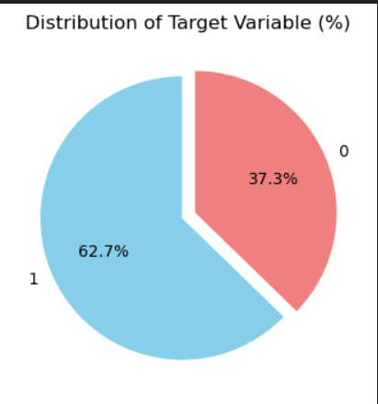
---﻿
4.2 Correlation with Target Variable﻿
correlation_matrix = df.corr(numeric_only=True)﻿
target_corr = correlation_matrix['target'].sort_values(ascending=False)﻿
Calculates correlation between features and the target.﻿
Helps identify which features strongly influence the target variable.﻿
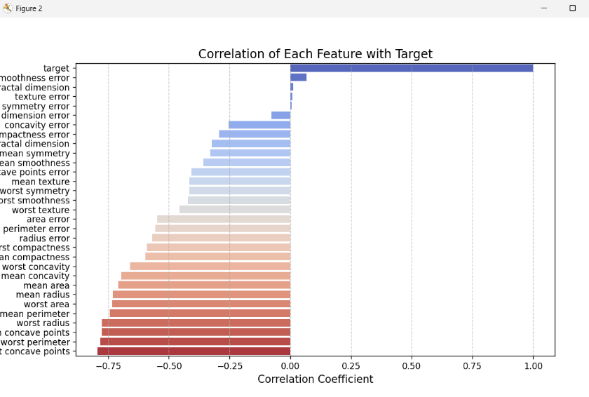

A bar plot is used to visualize feature-target correlation.﻿
---﻿
4.3 Correlation Heatmap﻿
sns.heatmap(correlation_matrix, annot=False, cmap='coolwarm')﻿
Displays correlation among all numerical features.﻿
Helps detect multicollinearity.﻿
Useful for feature selection and dimensionality reduction.﻿
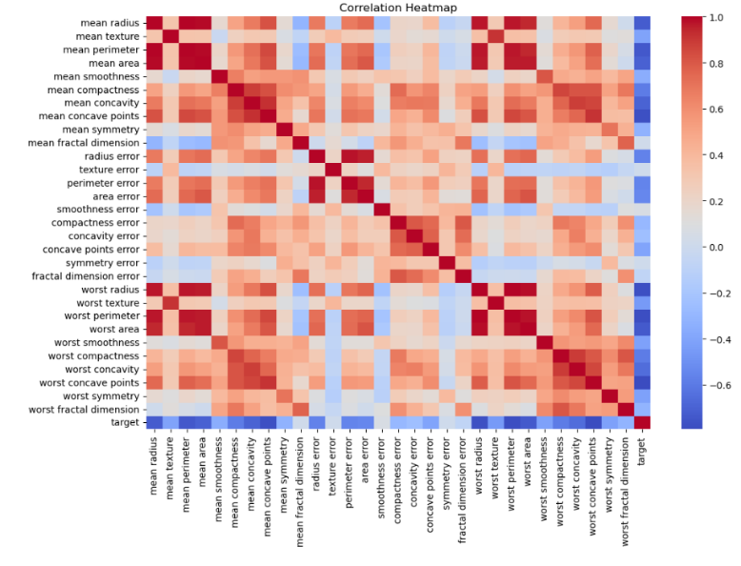

---﻿
5. Model Training and Evaluation﻿
5.1 Model Creation and Training﻿
model = LogisticRegression(random_state=42)﻿
model.fit(X_train, y_train)﻿
Logistic Regression is used for binary classification.﻿
The model learns relationships between features and target.﻿
---﻿
5.2 Making Predictions﻿
y_pred = model.predict(X_test)﻿
Predicts class labels (0 or 1) for test data.﻿
---﻿
5.3 Accuracy Score﻿
accuracy = accuracy_score(y_test, y_pred)﻿
Measures overall correctness of predictions.﻿
Accuracy = (Correct Predictions) / (Total Predictions)﻿
---﻿
5.4 Confusion Matrix﻿
confusion = confusion_matrix(y_test, y_pred)﻿
Shows:﻿
True Positives﻿
True Negatives﻿
False Positives﻿
False Negatives﻿
Useful for understanding classification errors.﻿
---﻿
5.5 Classification Report﻿
classification_report(y_test, y_pred)﻿
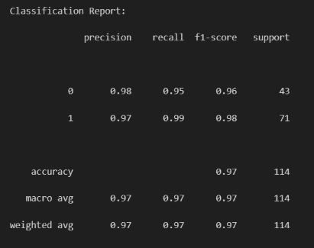

Provides:﻿
Precision: How accurate positive predictions are.﻿
Recall: How many actual positives were correctly predicted.﻿
F1-Score: Harmonic mean of precision and recall.﻿
Support: Number of samples per class.﻿
---﻿
6. Advanced Evaluation Metrics﻿
6.1 F-Beta Scores﻿
f2 = fbeta_score(y_test, y_pred, beta=2)﻿
f05 = fbeta_score(y_test, y_pred, beta=0.5)﻿
F2 Score:﻿
Gives more importance to recall.﻿
F0.5 Score:﻿
Gives more importance to precision.﻿
Useful when the cost of false negatives or false positives differs.﻿
---﻿
6.2 Log Loss (Cross-Entropy Loss)﻿
logloss = log_loss(y_test, y_pred)﻿
Measures how confident and accurate predictions are.﻿
Lower log loss indicates better probability predictions.﻿
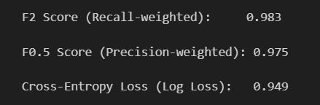

---﻿
7. ROC Curve and AUC﻿
7.1 Probability Prediction﻿
y_pred_prob = model.predict_proba(X_test)[:, 1]﻿
Returns probability of the positive class (class 1).﻿
---﻿
7.2 ROC and AUC Calculation﻿
roc_auc = roc_auc_score(y_test, y_pred_prob)﻿
fpr, tpr, _ = roc_curve(y_test, y_pred_prob)﻿
ROC Curve: Plots True Positive Rate vs False Positive Rate.﻿
AUC (Area Under Curve):﻿
0.5 → Random model﻿
1.0 → Perfect classifier﻿
---﻿
7.3 ROC Curve Visualization﻿
plt.plot(fpr, tpr, label='ROC curve')﻿
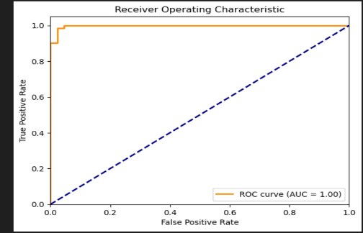

Shows the model’s ability to distinguish between classes.﻿
Higher AUC means better classification performance.﻿
---﻿
8. Final Conclusion﻿
The dataset is cleaned, scaled, and explored.﻿
Logistic Regression is trained for binary classification.﻿
Multiple evaluation metrics are used instead of relying only on accuracy.﻿
ROC-AUC confirms the model’s overall classification strength.﻿
---﻿
✅ This project demonstrates:﻿
Data preprocessing﻿
Exploratory data analysis﻿
Binary classification﻿
Model evaluation using industry-standard metrics

